**DAILY ONLINE ACTIVITIES SUMMARY**

|  |  |  |  |  |  |  |  |
| --- | --- | --- | --- | --- | --- | --- | --- |
| **Date:** | | **20/05/2020** | | | | | |
| **Name of the Faculty** | | **Shilpa** | | | | | |
| **No. of Students Allotted for monitoring** | | | | | **19** | | |
| **Progress** | | | | | **Good** | | |
| **Whether collected report from all the allotted students** | | | | | **14 submitted** | | |
| **Online Test Summary** | | | | | | | |
| **Subject** | **OOC IA TEST1** | | | | | | |
| **Semester** | **IV** | | | **Duration** | | **40 min** | |
| **No. of students Taken** | | | **94** | **Passing %** | | **96.4** | |
| **Certification Course Summary** | | | | | | | |
| **Course** | | **Network Server Security - Protecting the Server and Client Computers** | | | | | |
| **Certificate Provider** | | **Alison** | | | **Duration** | | **2-3 Hours** |
| **Coding Challenges** | | | | | | | |
| **Problem Statement: - Write a JAVA Program to Print Duplicate Array Elements** | | | | | | | |
| **Status: - 10** | | | | | | | |
| **Uploaded the report in Github** | | | | | **YES** | | |
| **If yes Repository name** | | | | | <https://github.com/shilpahassan/Daily-Report> | | |
| **Uploaded the report in slack** | | | | | **YES** | | |

Online Test Details: (Attach the snapshot and briefly write the report for the same)

Certification Course Details: (Attach the snapshot and briefly write the report for the same)

Coding Challenges Details: (Attach the snapshot and briefly write the report for the same)

Online Test Summary

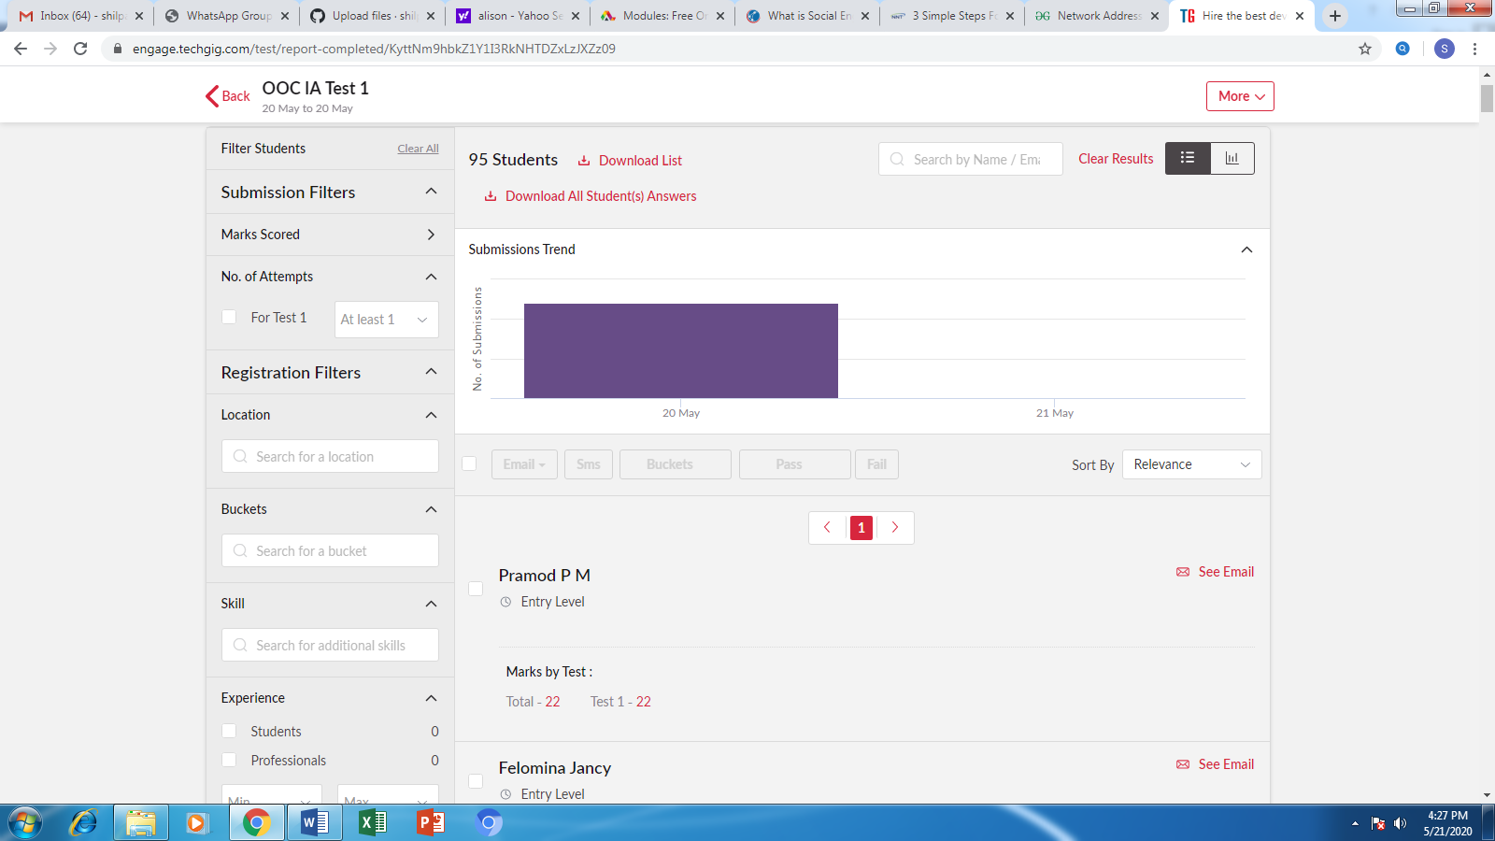

**Certification Course Summary**

There are 3 modules in the certification course, I completed 2nd module.

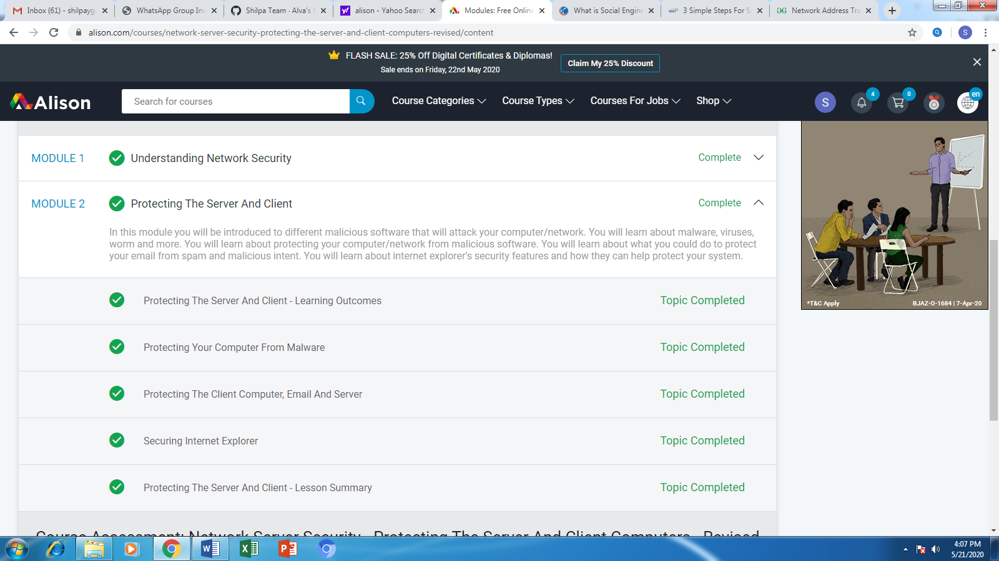

**Students Report:**

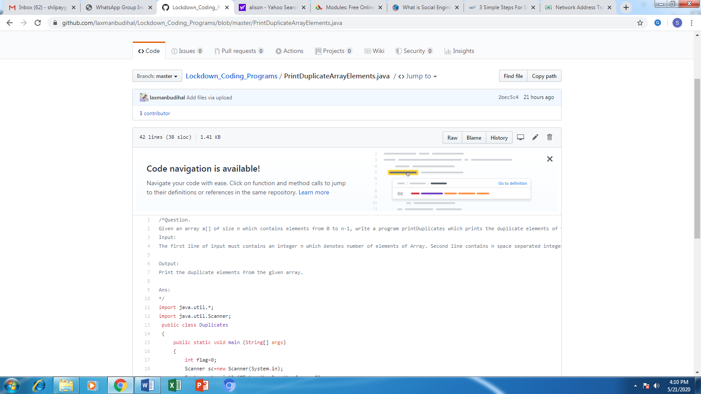

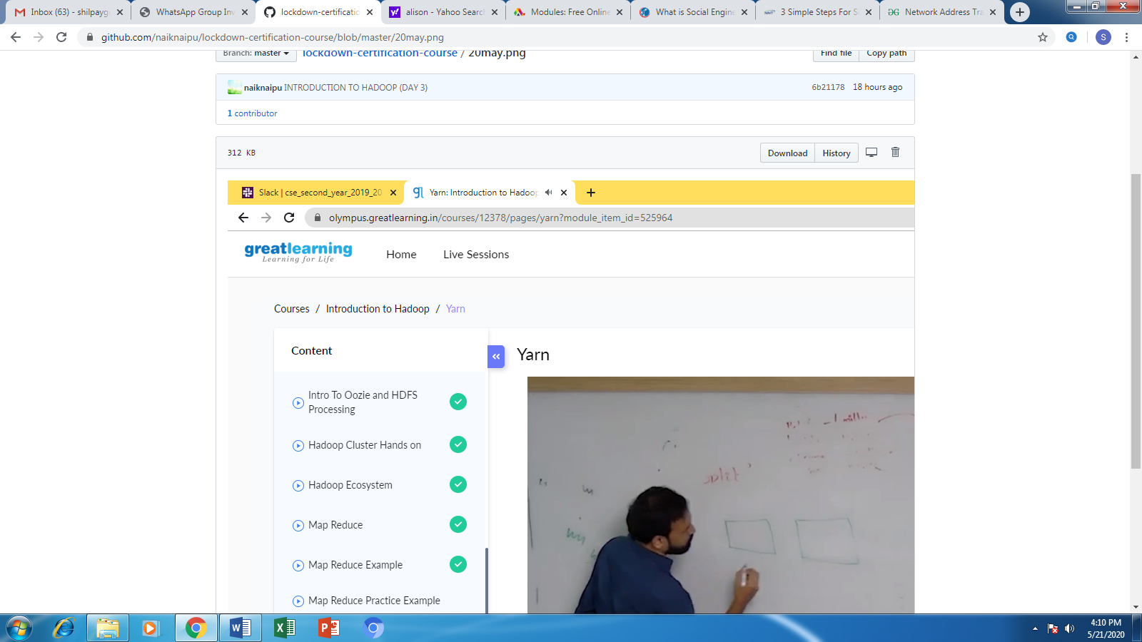

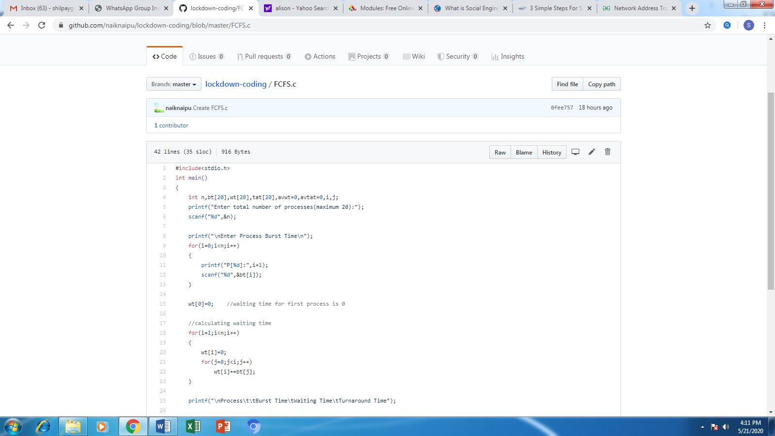

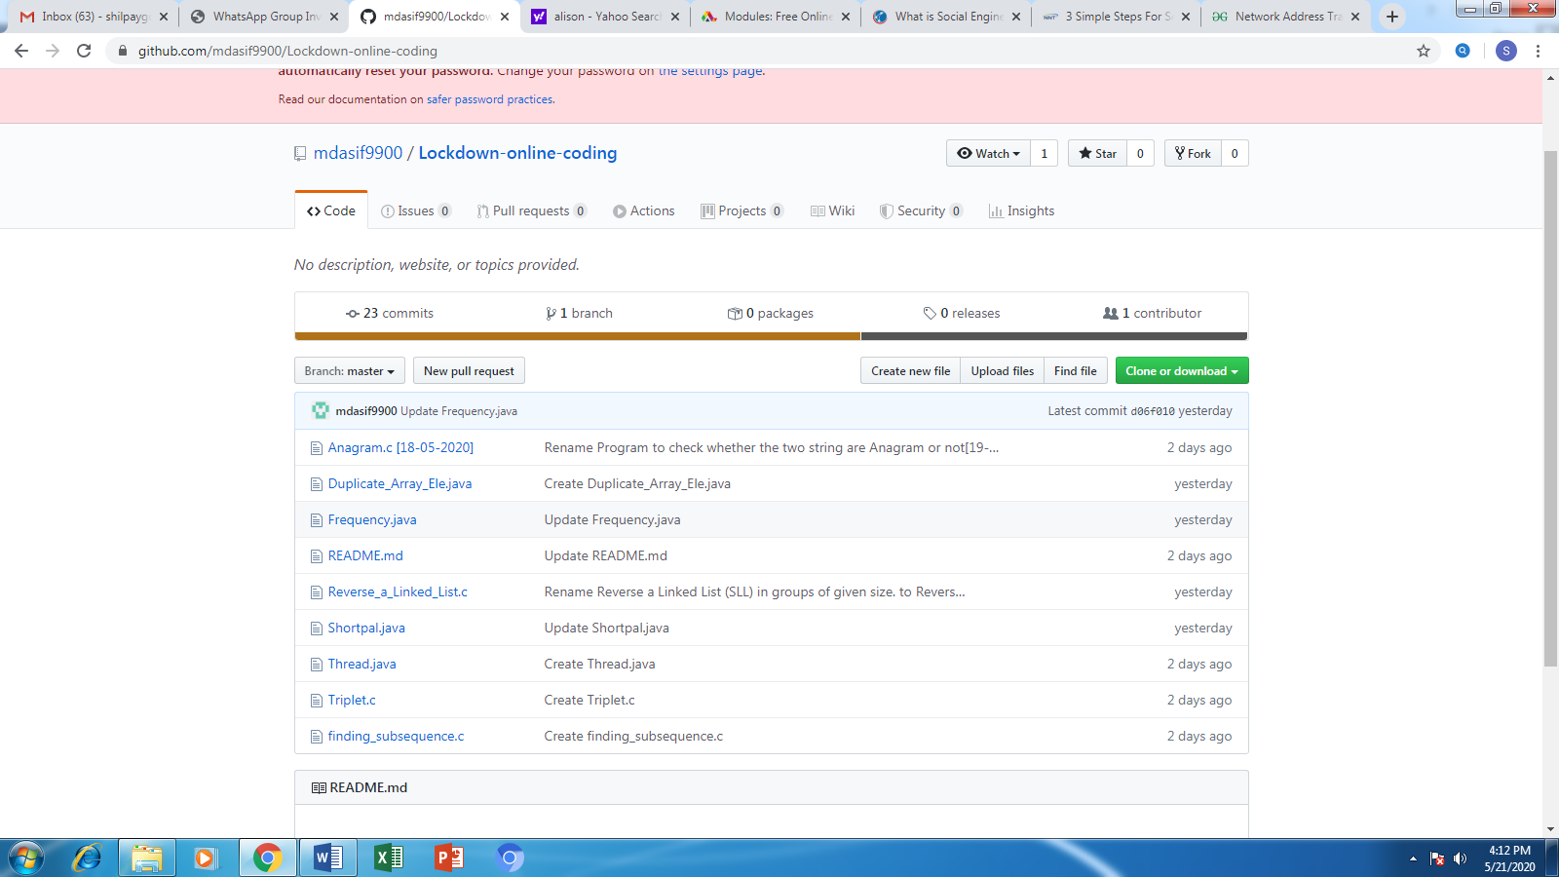

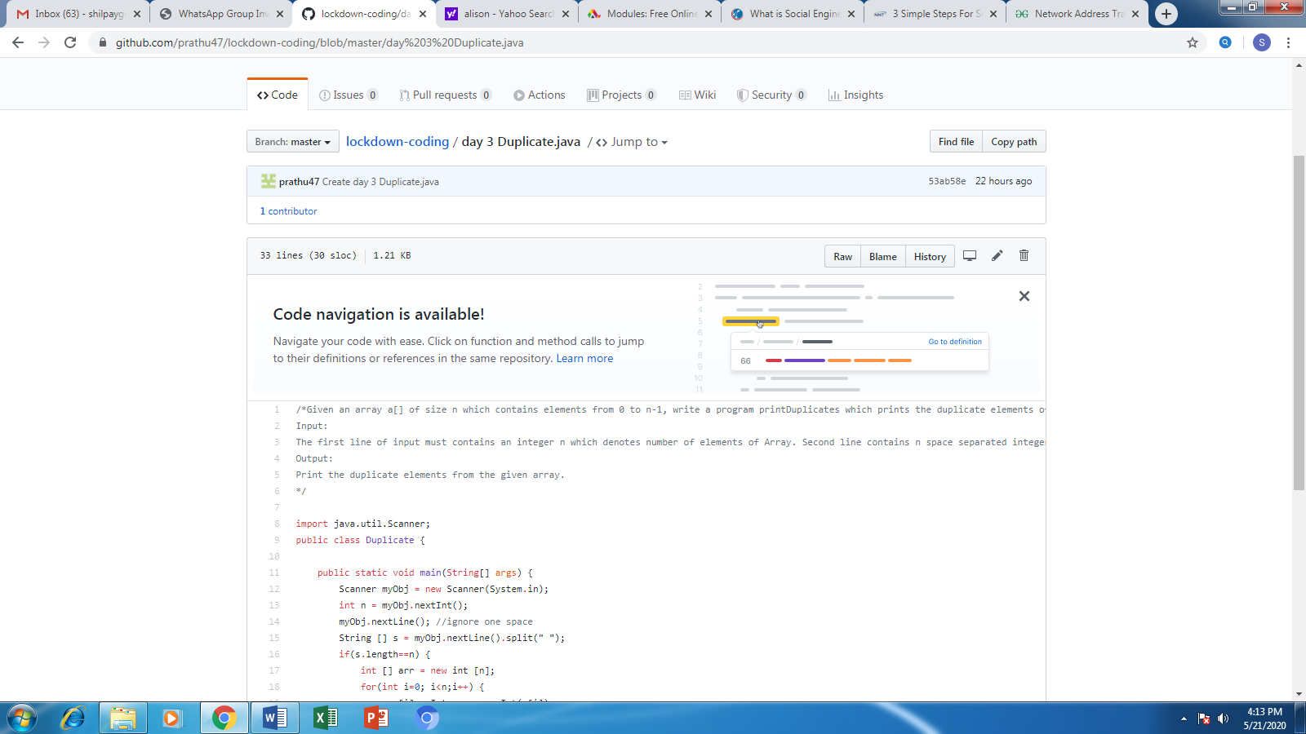

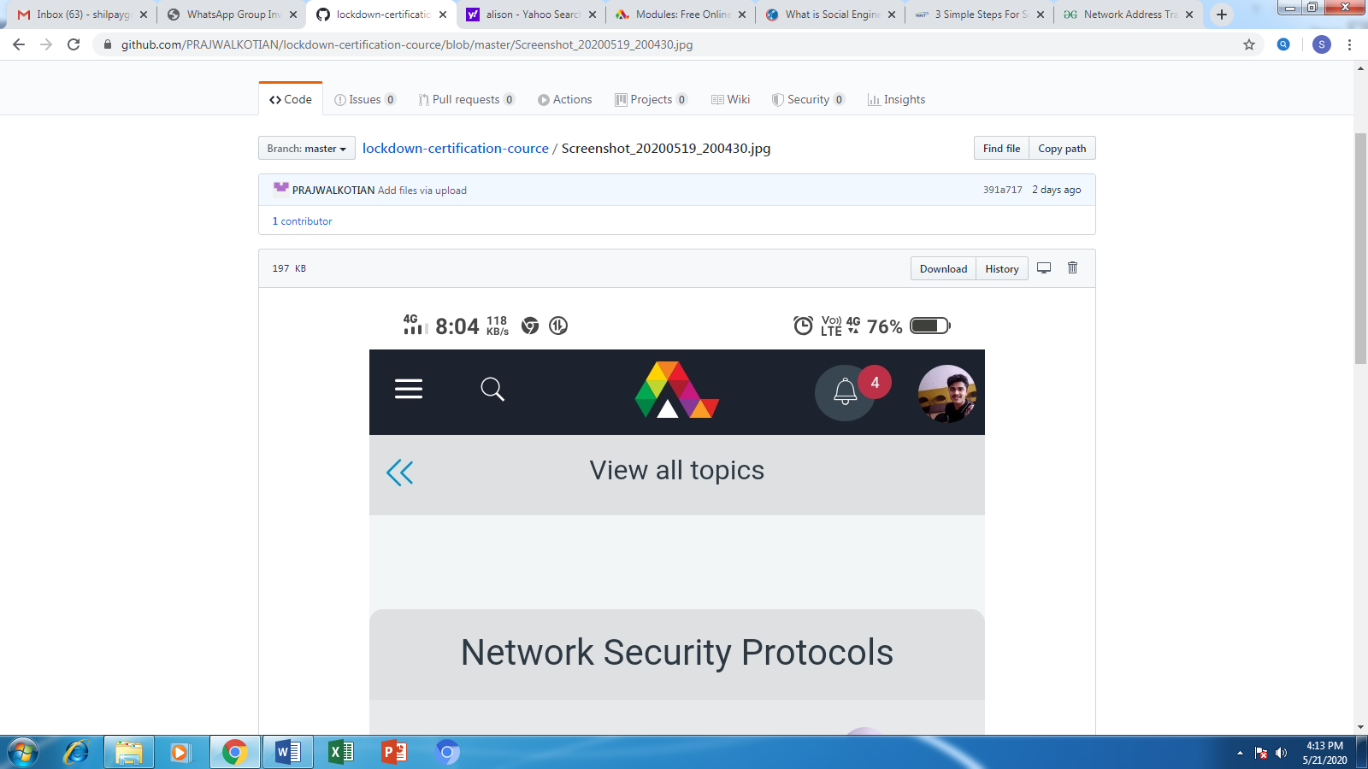

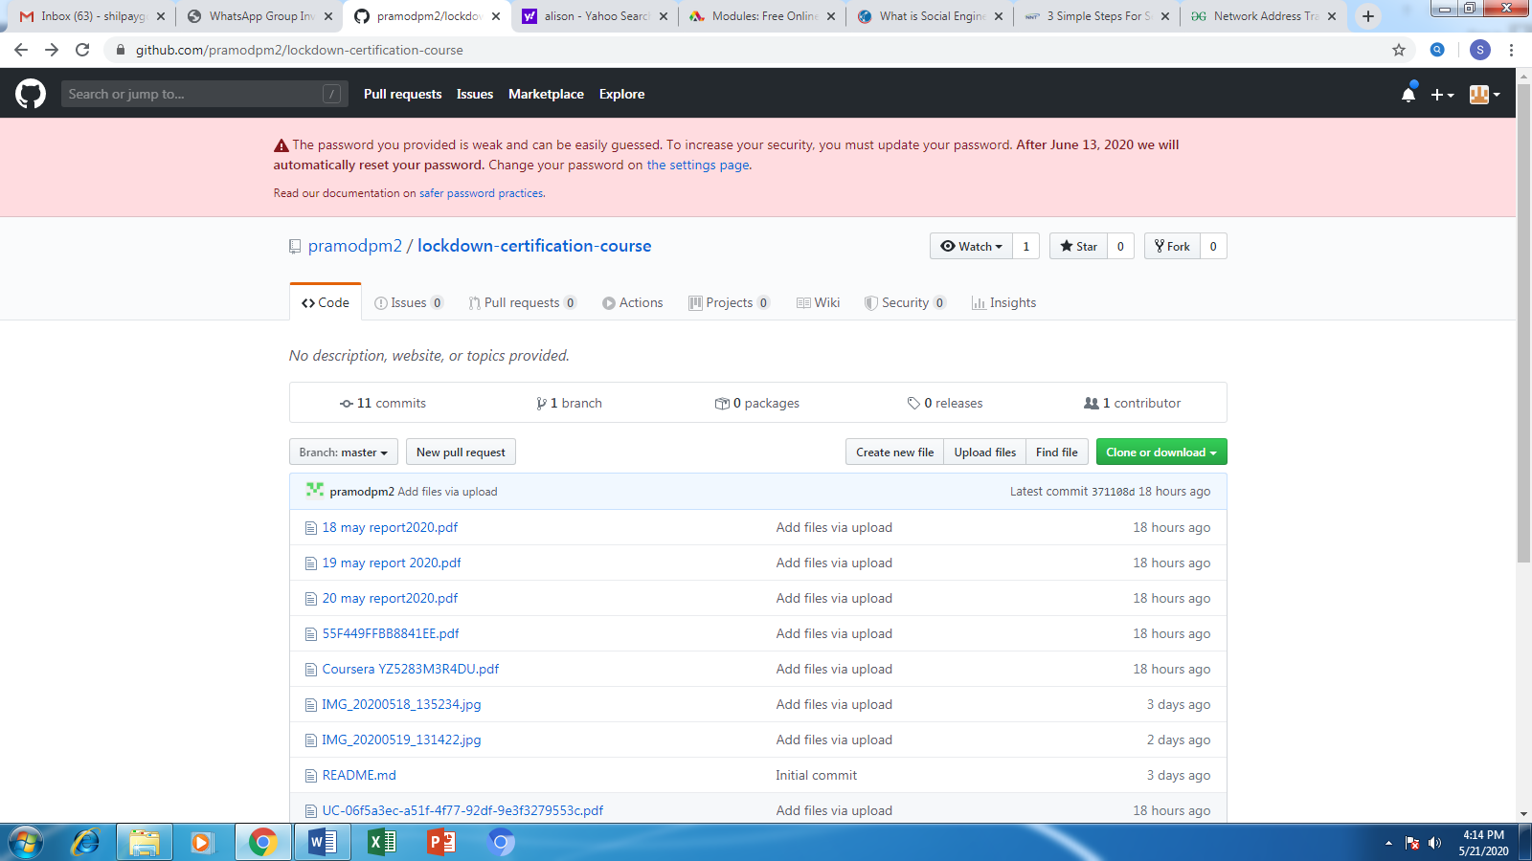

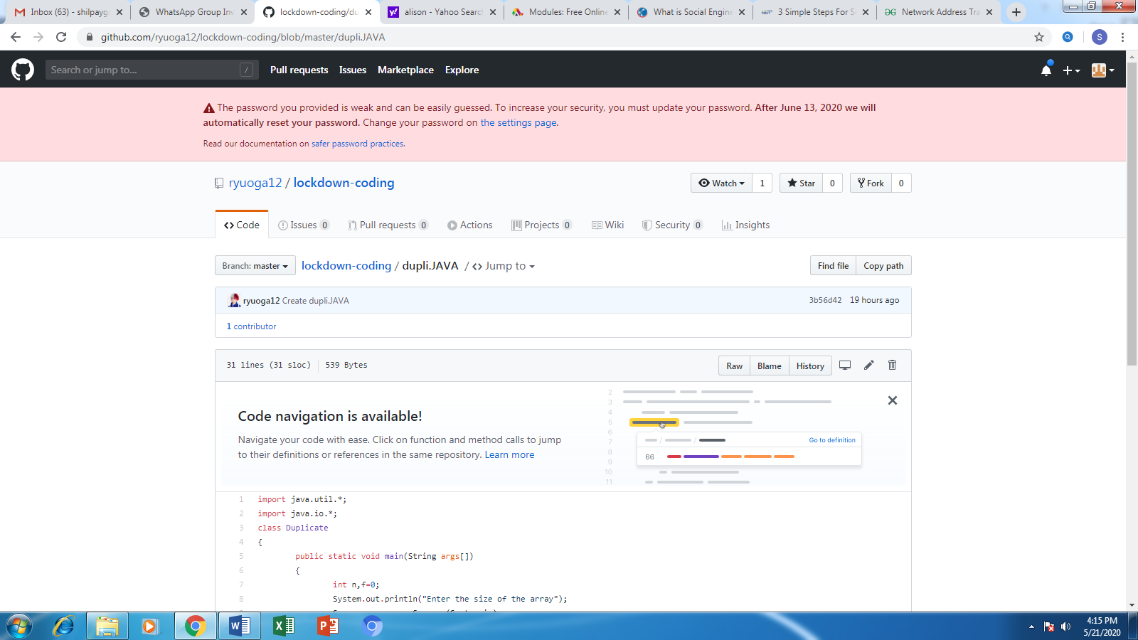

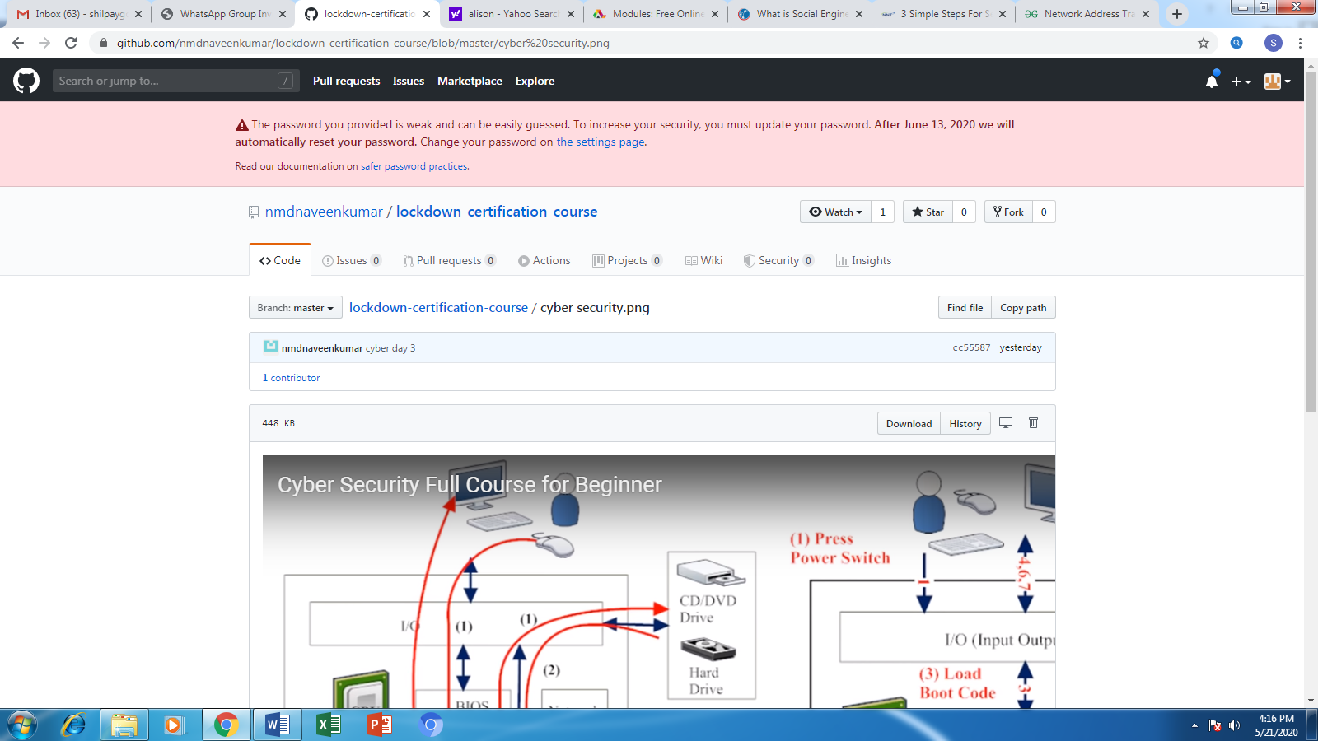

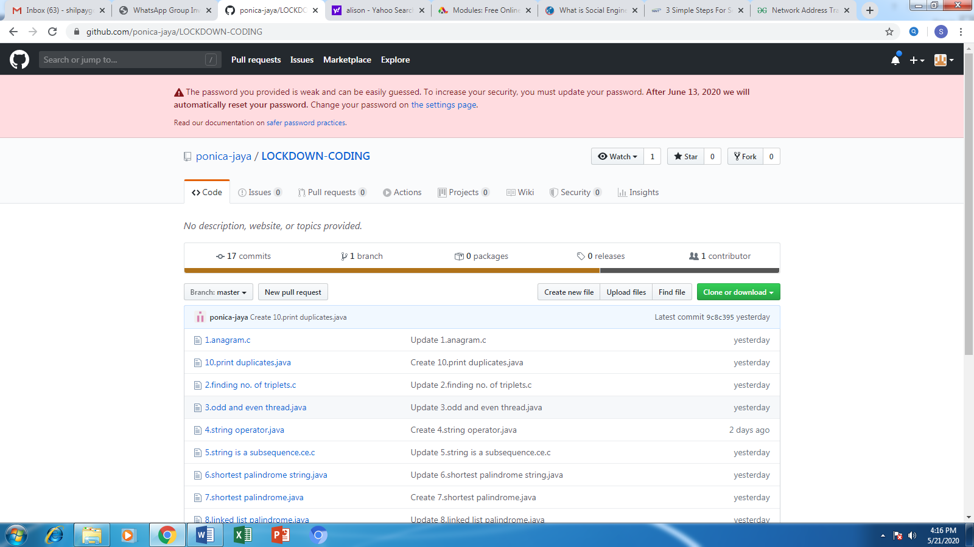

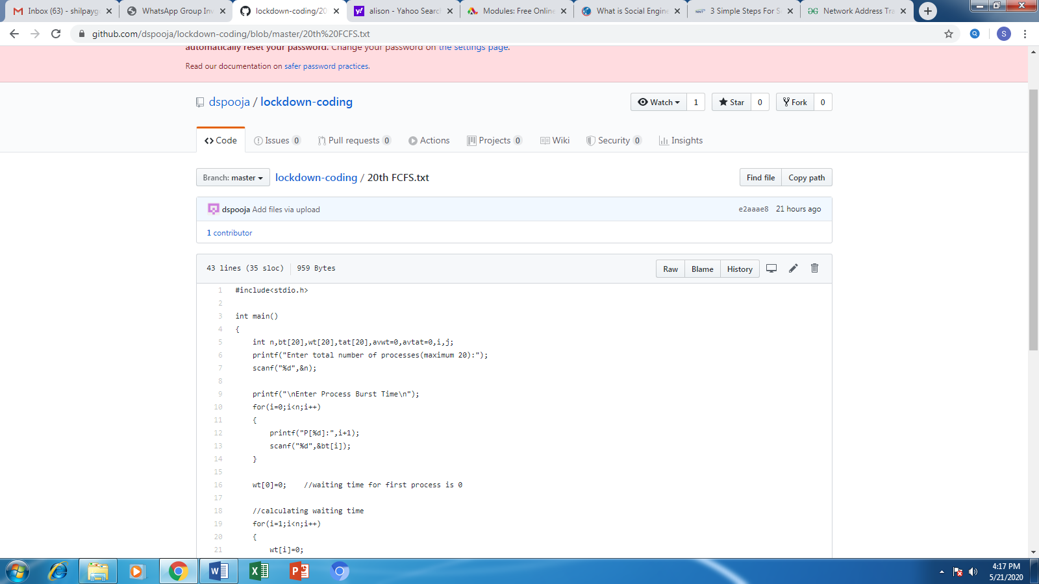

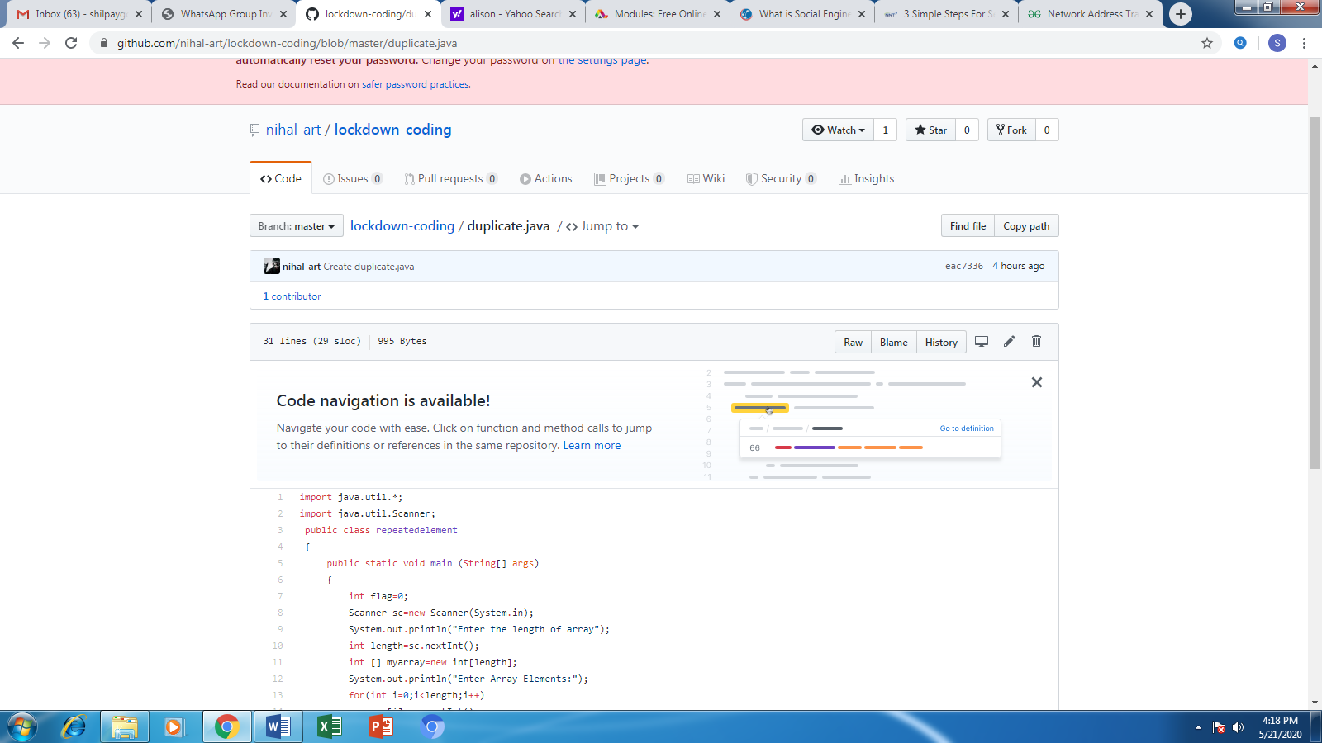

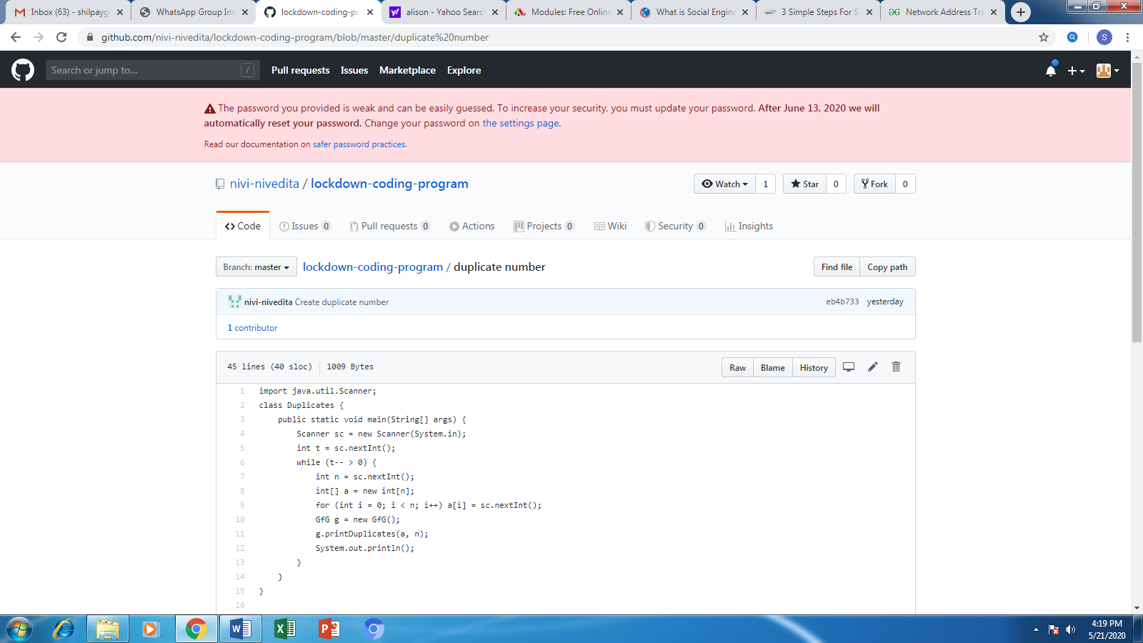

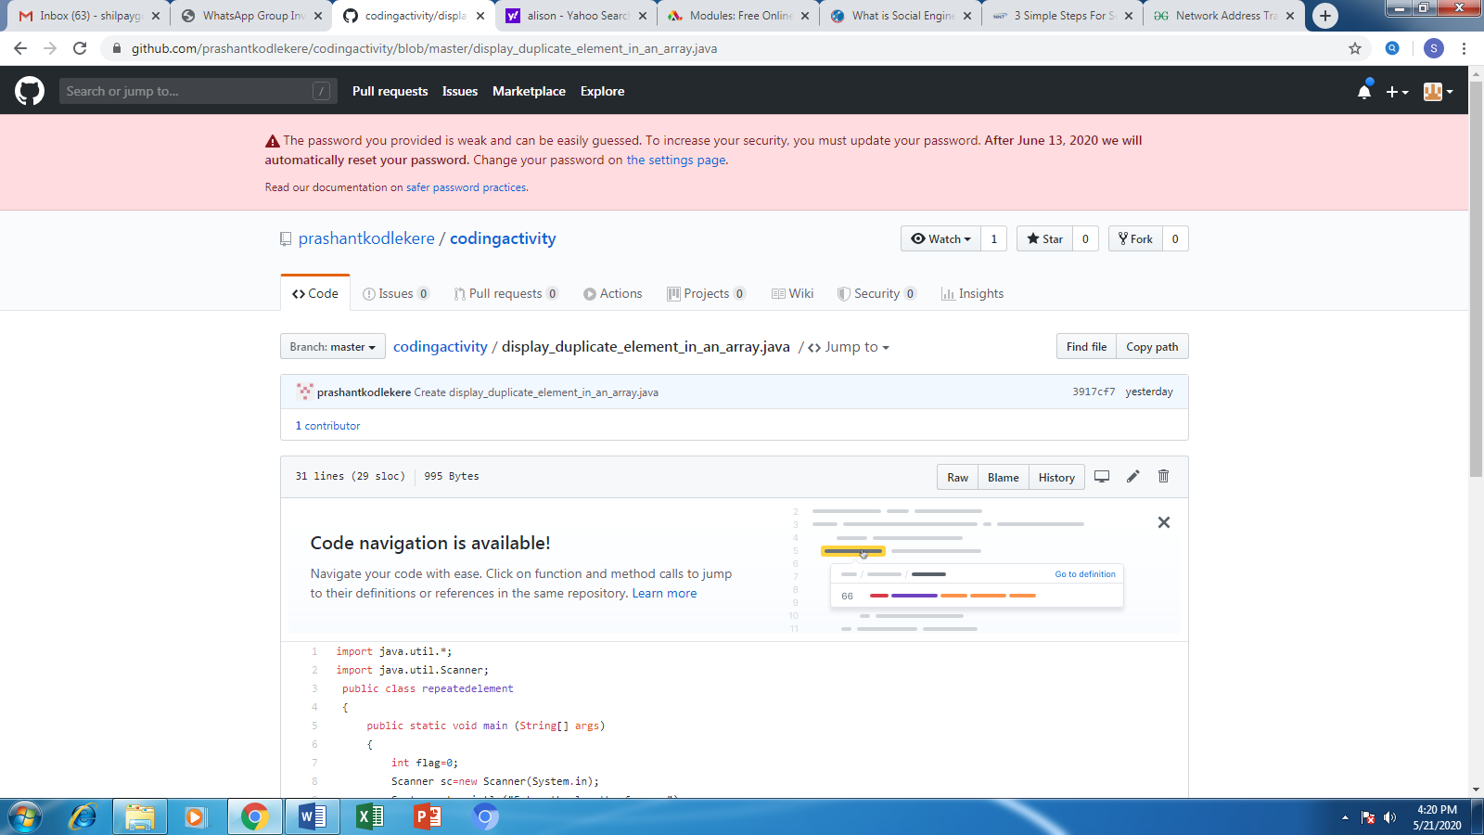

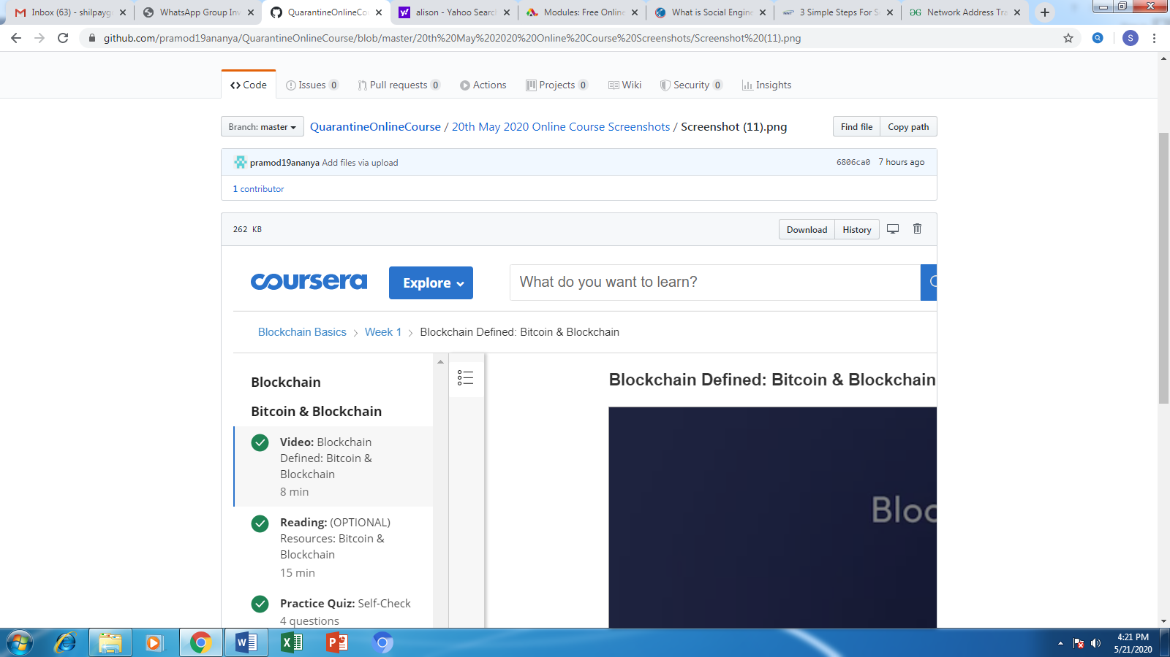

**Coding Challenge**

